Task 1: - Log in to your home Wi-Fi router's admin panel using its default IP address (usually 192.168.0.1 or 192.168.1.1) and take a screenshot of the login page you don't know your router's IP, open Command Prompt and run 'ipconfig' — look for 'Default Gateway'
Step 1: Find your router’s IP address
- Press Windows + R.
- Type cmd and press Enter.
- Run:
ipconfig
4. Find Default Gateway under your active Wi-Fi adapter. For example, 192.168.1.1.
Step 2: Open the login page
- Open Chrome.
- Enter your Default Gateway in the address bar, for example, http://192.168.1.1.
- Press Enter. Your router’s login page should appear.
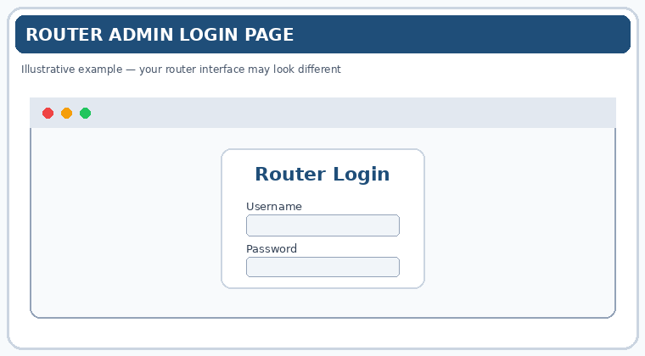
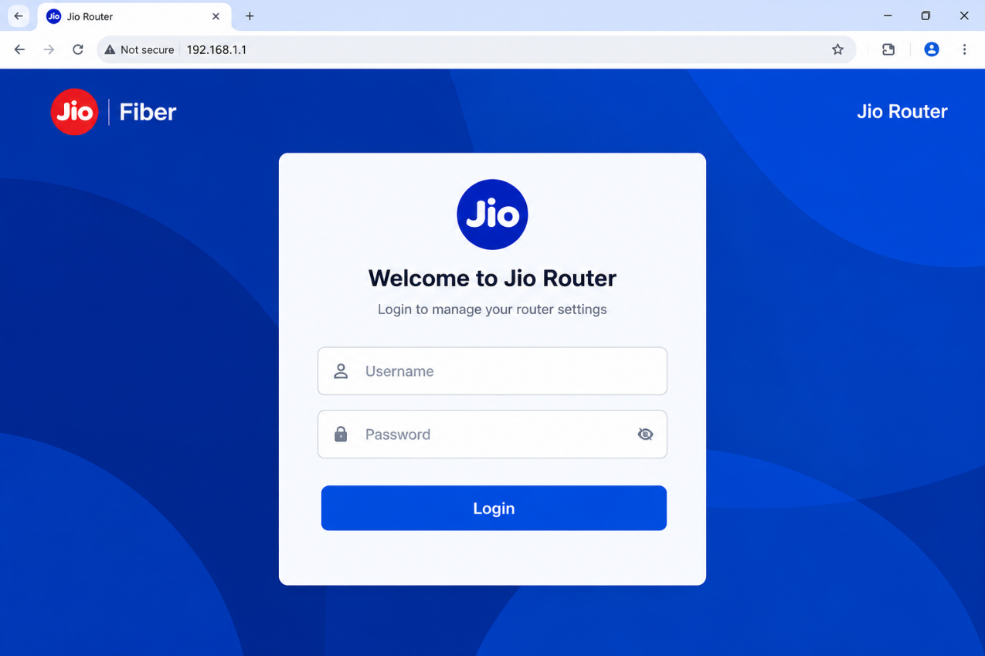

Task 2: - Find and note down the current IP address, subnet mask, and default gateway assigned to your laptop or mobile device when connected to your Wi-Fi network.

Practical: Find Current Wi-Fi Network Settings
Procedure (Windows laptop):
- Connect your laptop to your Wi-Fi network.
- Press Win + R, type cmd, and press Enter.
- Type ipconfig and press Enter.
- Under Wireless LAN adapter Wi-Fi, note the IPv4 Address, Subnet Mask, and Default Gateway.
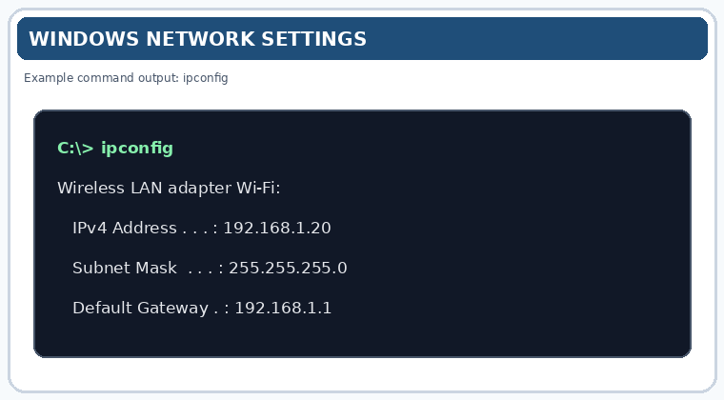
Observation Table
Parameter | Value (example)
IP Address (IPv4) | 192.168.1.20
Subnet Mask | 255.255.255.0
Default Gateway | 192.168.1.1

Task 3: -Change your device's IP address from 'Obtain IP automatically' (DHCP) to a static IP in the same range as your router (for example, set it to 192.168.1.50 if your router is 192.168.1.1), and test if you still have internet access. Remember to revert to automatic/DHCP after testing to avoid network issues.
Practical: Change DHCP to a Static IP Address and Test Internet Access
1. Procedure
- Connect your Windows laptop to your Wi-Fi network.
- Open Settings → Network & Internet → Wi-Fi.
- Select your connected Wi-Fi network and find IP assignment.
- Click Edit and change Automatic (DHCP) to Manual.
- Enable IPv4 and enter the static network settings.
Example configuration
Assuming your router's default gateway is 192.168.1.1 and the subnet mask is 255.255.255.0:
Setting | Value
IP address | 192.168.1.50
Subnet mask | 255.255.255.0
Default gateway | 192.168.1.1
Preferred DNS | 8.8.8.8
Alternate DNS | 1.1.1.1
Important: These values are examples. Use the same network range as your actual router, and ensure the chosen IP address is not already in use.
6. Click Save and reconnect to Wi-Fi if necessary.
2. Test the Internet Connection
Open Command Prompt and run:
ping 192.168.1.1
ping 8.8.8.8
Replace 192.168.1.1 with your actual default gateway if different. Then open a website in your browser.
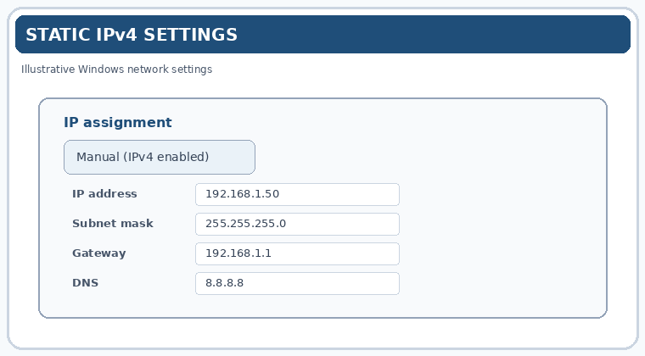
Test | Expected result
Ping router gateway | Successful
Ping 8.8.8.8 | Successful, unless ping is blocked
Open a website | Internet access working
3. Restore Automatic (DHCP)
After testing:
- Return to Settings → Network & Internet → Wi-Fi.
- Open your connected network's IP assignment → Edit.
- Select Automatic (DHCP).
- Save and reconnect to Wi-Fi.
- Run ipconfig to verify the settings have been assigned automatically.

Task 4: -In your router's admin panel, locate the section where you can view or change the DHCP range. Write down the current range, and explain in 2-3 lines what would happen if two devices are assigned the same IP address in this range.
Practical: Check the DHCP Range in the Router Admin Panel
1. Procedure
- Connect your device to your home Wi-Fi.
- Open Command Prompt and type ipconfig to find the Default Gateway.
- Enter the gateway address in your browser, for example, http://192.168.1.1.
- Log in to your router's admin panel.
- Navigate to LAN Settings, Local Network, or DHCP Server to locate the DHCP address range.
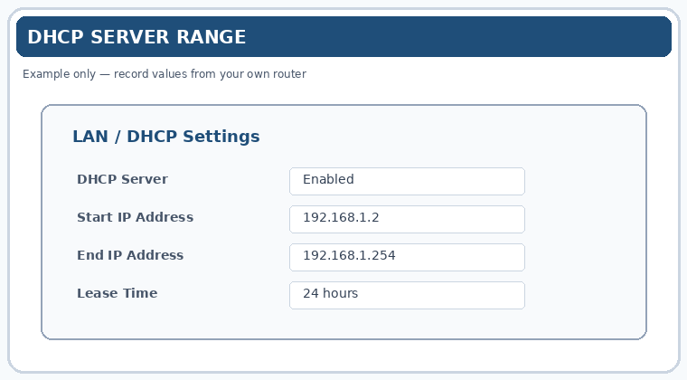

2. Observation Table
Setting | Value
Router brand | Jio Fiber (example)
DHCP start IP | 192.168.1.2 (example)
DHCP end IP | 192.168.1.254 (example)
Note: These are example values, not verified settings for your Jio router. Record the actual range displayed in your admin panel.
3. What happens if two devices have the same IP address?
If two devices are assigned the same IP address on the same local network, an IP address conflict occurs. Network communication may become unreliable, causing connection failures, intermittent internet access, or packets being delivered to the wrong device.

